|  |  |
| --- | --- |
| **Name** | **Enayathulla A** |
| **Date** | **08/01/2024** |
| **Type** | **Daily Assignment** |
| **Topic** | **Azure DevOps** |

**DevOps:**

* Development + Operations = DevOps
* DevOps is the union of people, process, and products to enable continuous delivery of value to your end users.
* DevOps is a set of practices, tools, and a cultural philosophy that automate and integrate the processes between software development and IT teams. It emphasizes team empowerment, cross-team communication and collaboration, and technology automation.

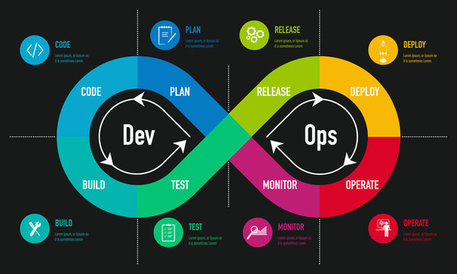

**Azure DevOps:**

* Azure DevOps provides an integrated set of services and tools to manage your software projects, from planning and development through testing and deployment. Azure DevOps delivers services through a client/server model.
* Azure DevOps provides lot of services. These are
  + Azure Boards
  + Azure Pipelines
  + Azure Repos
  + Azure Test Plans
  + Azure Artifacts

**Azure pipelines:**

Azure Pipelines automatically builds and tests code projects. It supports all major languages and project types and combines continuous integration, continuous delivery, and continuous testing to build, test, and deliver your code to any destination.

**Azure Boards:**

Azure Boards is a web-based service that enables teams to plan, track, and discuss work across the entire development process, while it supports agile methodologies, including Scrum and Kanban.

**Azure Repos:**

Azure Repos is a set of version control tools that you can use to manage your code. Whether your software project is large or small, using version control as soon as possible is a good idea. Version control systems are software that helps you track changes you make in your code over time.

**Azure Test Plans:**

Azure Test Plans is a test management module within Azure DevOps that lets users manage test plans, test suites, and test cases for everyone in the software development process. Using test plans, you can Azure Test Plans also provides a browser extension for exploratory testing and gathering feedback from stakeholders.

**Azure Artifacts:**

Azure Artifacts enables developers to efficiently manage all their dependencies from one place. With Azure Artifacts, developers can publish packages to their feeds and share them within their team, across organizations, and even publicly across the internet.

**Azure DevOps main focus:**

* Continuous Integration (CI)
* Continuous Deployment (CD)
* Continuous Learning & Monitoring

**Continuous Integration (CI):**

Continuous integration is a DevOps software development practice where developers regularly merge their code changes into a central repository, after which automated builds and tests are run. Continuous integration most often refers to the build or integration stage of the software release process and entails both an automation component (e.g. a CI or build service) and a cultural component (e.g. learning to integrate frequently). The key goals of continuous integration are to find and address bugs quicker, improve software quality, and reduce the time it takes to validate and release new software updates.

**Continuous Deployment (CD):**

Continuous deployment is a strategy in software development where code changes to an application are released automatically into the production environment. This automation is driven by a series of predefined tests. Once new updates pass those tests, the system pushes the updates directly to the software's users.

**Continuous Learning & Monitoring:**

Continuous learning is a machine learning approach that enables models to integrate new data without explicit retraining. It builds upon traditional machine learning fundamentals in a way that addresses the dynamic essence of real-world data, creating adaptable models that can improve machine performance over time.